MINUTES OF THE ANNUAL GENERAL MEETING
OF ELLISWICK LAWN TENNIS CLUB
SATURDAY 26th NOVEMBER 2022 AT 10:30AM
AT THE CLUBHOUSE

In the absence of the Club’s Chairman, the President, Jim McGown (JM) chaired the Club’s 98th AGM commencing at 10:30 am.
He welcomed all attendees and pointed out the fire exits. JM said that Eric Rovick (ER) was unable to be present to chair the AGM as he had been exposed to Covid. As President, JM would accordingly chair the meeting.
- Apologies
Sally Radcliffe (SR) tallied apologies/proxies and informed the meeting that 39 members were present, and 90 proxies and 5 apologies had been received. The Club Secretary, David Kendall (DK), declared that the meeting was accordingly quorate.
Directors Present: JM, DK, Jaap Hesselink (JH), Kate Curson (KC), Sue Cove (SC), ER (by telephone)
Other Committee Members Present : SR, Jeanette Rickerty (JR), Ken Michie (KM), Andree Haxton (by telephone)
- Approval of minutes of AGM held on 20th November 2021 and matters arising
Tony Ward (TW) proposed and Tony Wills (AW) seconded the motion to approve the minutes of the AGM held on 20th November 2021 as a true and accurate record of the meeting. The motion was passed unanimously. JM said that there were no matters arising
- Adoption of the Committee Members’ reports of the activities of the Club for the year
JM summarised the main points of the Chairman’s Report distributed with the AGM papers. Thanks were given to many members who had assisted in the running of the Club over the last year. Presentations were made to the retiring Committee members JR, SC, and KM. Rupert Tilbrooke and Nefyn Provis-Evans were thanked in absentia.

Norman Hoare (NH) proposed and Paul Templeman (PT) seconded a motion to adopt the Committee's written reports of the activities of the Club for the 2021/22 year. The motion was passed unanimously.
- Financial Matters
  - Adoption of the Club’s Accounts
JH gave a presentation on the accounts to the year ending 30 September 2022. The Club’s income had risen by £6,565 and its expenditure decreased by £466 compared to 2020/21.

DK said that the accounts had been prepared by JH, TW, ER and the accountants Hicks and independently reviewed by Nigel Martin (NM) in the same way as in previous years. They were considered to give a fair picture of the year. NM had confirmed that he had found nothing to suggest that the Profit & Loss and Balance Sheet for the year ended 30 September 2022 was not in accordance with the explanations given to him.

DK reported that following consultation by TW with a firm of accountants, it was considered likely that the independent accountant’s review did not satisfy the requirement in the Articles that the accounts be subject to a non-statutory audit. No member asked for the accounts to be audited.

Tom Walters proposed and Miles Radcliffe seconded the motion that the Club's financial accounts for the year ending 2021/22 be approved. The motion was passed unanimously.

DK said that the requirement in the Articles for the annual accounts to be audited was very unusual for a club like Elliswick. There was no statutory requirement for the accounts to be audited and it was common for a club’s accounts to be subject only to an independent accountant’s review. In the circumstances, it was proposed to ask the membership to agree to amend the Articles during the course of 2023.

TW was to step down from the task of preparing the accounts next year and would be replaced either by a volunteer or an external firm of accountants to prepare and review the accounts if considered by the Committee to be more efficient. NM had agreed to review the 2022/23 accounts if required.

TW proposed and NH seconded a motion to appoint, as the Club’s independent examiner, either Nigel Martin or an alternative acceptable to the Committee, or a firm of auditors acceptable to the Committee if necessary. The motion was passed unanimously.
  - Update of the Club’s 5 Year Plan

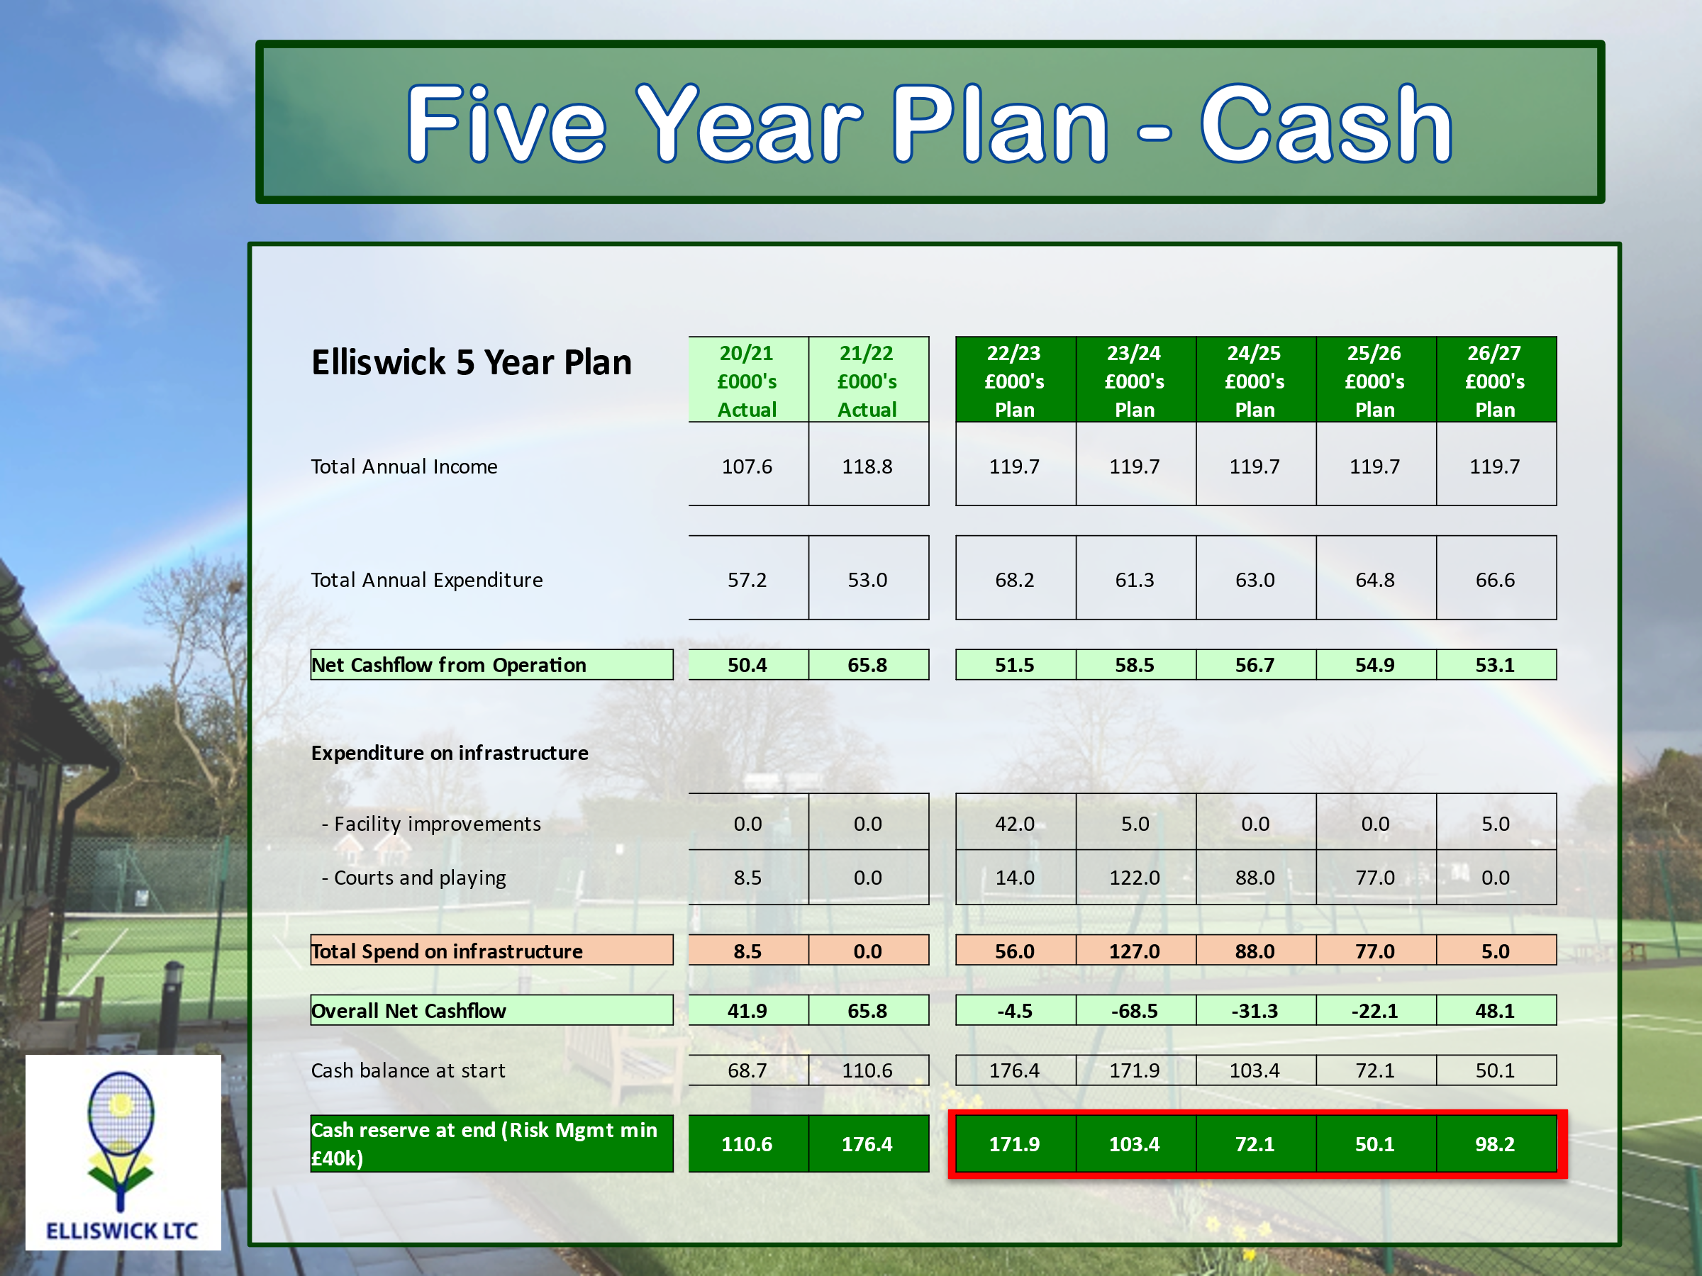
JM presented the Club’s Five-Year Plan as set out in the attached slide. He confirmed that the plan is based on cash accounts. The main areas of capital expenditure were the clubhouse, the courts and the grounds.
The numbers in the 5-year plan look slightly different to the financial accounts just approved in that the plan is based on cash accounts.
The plan addressed the club’s income and the investments the club should make to ensure a safe and excellent environment for tennis, including its coaching programme, and for its social events.
Specifically, the club makes investments in three areas: the clubhouse, the courts and, sometimes, the grounds (eg car park, paths).
Overall the 2021/22 operating cash flow rose from £50.4k to £65.8k as cash income outpaced cash expenditure but this year’s cash flow was flattered by the timing of payments for floodlight maintenance and an outsized water bill, which JH mentioned earlier, which came after 30th September.
Cash income is expected to remain roughly flat but cash expenses are due to rise due to inflation, particularly for electricity, as well as the aforementioned items. The forecast is for operating cash flow to fluctuate between £50k and £60k throughout the 5 years 2022/23 – 2026/27 on the basis that the club is at full membership with a healthy waiting list and manageable cash expenses, with inflation identified at present as our main risk.
There were no infrastructure investments in 2021/22, as forecasted a year ago.
Going forward, most of planned investments moved out by a year given the delays in obtaining floodlight planning permission and the currently favourable state of the courts. Though delayed in time, the court and floodlight investment plans are roughly the same as presented in last year’s plan, with the budgeted costs increased by 10% to allow for inflation.
2022/23 Deep cleaning of courts 1-3, solar panel installation
To prolong the life of courts 1-3, a deep clean and rejuvenation is proposed for this year at a total cost of £14k, which will allow the full court resurfacing to be moved out beyond the scope of the 5-year plan. The one new proposed project is the installation of solar panels on the roof of the clubhouse. Up to £40k has been budgeted for the panels, battery and installation, although it is hoped to be able to do this for less than that. Quotes are being obtained. £2k has been budgeted for minor facility redecoration, yet to be determined.
2023/24 Renewal of courts 4~7 artificial grass surface, prep for floodlight replacement
Courts 4~7 were last resurfaced in 2008 and works to replace the court surface are now being budgeted for 2023/24. The deep clean of courts 4-7 has given them a longer useful life.
In that year it is also proposed to undertake the groundworks for new floodlight installations, as the two projects should be caried out simultaneously. The court work, including groundwork, is budgeted at £122k. It is also proposed to lay the path to the junior courts in that year.
2024/25 Floodlights courts 5 + 6
A sum of £88k has been included in 2023/24 for potential new floodlights for courts 5 and 6. Fixed-mast floodlights on the lower courts would be ideal, but the initial planning application for these was refused. The next planning application does again contemplate fixed masts, but planning permission is not certain. Thus, for purposes of the plan, the worst-case scenario has been budgeted for which contemplates replacement of the existing mechanical retractable floodlights with pneumatic retractable floodlights.
2025/26 Floodlights courts 4 + 7
A sum of £77k has been included in 2025/26 for pneumatic retractable floodlights on courts 4 and 7. A decision cannot be taken on further floodlights for courts 4 and 7 until the plans for courts 5 and 6 have been finalised, and in any case, will need to be discussed and potentially approved in a future AGM as well as be granted planning permission.
2026/27 No big projects
With the envisaged investments in courts and floodlights in the first four years of this plan, in 2026/27 the club should once again be in a position of low capital expenditure for a couple of years such that only £5k has been budgeted for miscellaneous work, potentially including some redecoration for the clubhouse. This will enable the club to start to rebuild its cash reserves.
JM stated that over the years we have acted prudently, keeping cash reserves at 50% of turnover to enable us to deal with unexpected contingencies.
JM then asked for any comments or questions.
TW asked for clarification as to what is happening on courts 1-3. JM explained that they have extra life because the depreciation has not been as much as we expected, but that a deep clean is planned.
Steve Segall asked why we are no longer looking at floodlights for courts 1 and 2, which in the past, was considered a better bet than courts 6 and 7, as they are farther from neighbours. JM said the planning committee would look into this.
There was a discussion about the potential cost of solar panels. David Cowan said that a large battery capacity was needed, and said he thought the cost would be £20-30,0000. Phil Benson pointed out that LED lights in the new floodlights would only use 30% of the power currently needed.
TW proposed and AW seconded a motion to adopt the investment plan for 2022/23. The motion was passed unanimously.
NH proposed and Pierre Oliviere (PO) seconded a motion to adopt the five-year investment plan as it presently stood. The motion was passed unanimously.

  - To fix the membership entrance fees and subscription levels for 2023 and dates subscriptions due.
JM explained the membership fee strategy: zero fee increases for the next few years as the 5-year plan shows that even with heavy investment we can afford not to increase subs; however, if the current high level of inflation affects our cost base more than expected, we may need to increase subs at some point. For 2023 we are proposing no increase in either the membership entrance fees or the subs.
MR proposed and Mhairi De Kort seconded a motion to adopt the Committee's recommendation of no increase in membership fees for the year 2022/23 and the due date for fee payment of 1 March 2023. The motion was passed unanimously.
- To elect/re-elect officers
DK stated that as no other candidates had come forward, the following are elected to the following Committee positions:
Chairman and Director: Eric Rovick
Secretary and Director: David Kendall
Treasurer and Director: Jaap Hesselink
Ladies Captain and Director: Kate Curson
Men’s Captain and Director: Jeremy Collier-Garrity
Mixed Team Captain and Director: Tony Ward
Grounds Officer and Director: Dave Cowan
Membership Secretary: Sally Radcliffe
Social Secretary: Jane Bisseker
Junior Secretary: Pierre Oliviere
Tournament Secretary: Louise Behan
- To consider any other business submitted in writing to the Secretary
JM said that a member had asked whether a clock could be installed on top of the clubhouse visible to all the courts. ER had noted that a clock may not be compatible with the proposed solar panels and may be unacceptably expensive. Some members expressed the view that a clock was not necessary while others suggested that it may be an appropriate way to celebrate the Club’s centenary. JM said that the Committee would investigate the proposal further.
- To fix the date of the next AGM
JM proposed that the next AGM be held on 2nd December 2023. TW asked whether it could be held on 9th December 2023 to allow more time for the annual accounts to be prepared. PO suggested that the year end date be brought forward to 31st August to allow more time. DK suggested that 2nd December 2023 be agreed for now and that the date be reviewed in light of changes to the Articles to be proposed in 2023 which may impact the preparation of accounts.
NH wanted to extend a big thank you to Eric Rovick and Andree Haxton for all they do to ensure the successful running of the club, which he described as “a gem in Harpenden”.
JM thanked members for attending and declared the meeting closed at 11:35 am.

